AWS Assignment

1• **Create a virtual network with 2 subnets. Each subnet should have 16 Ips only.**

**Creating VPC**

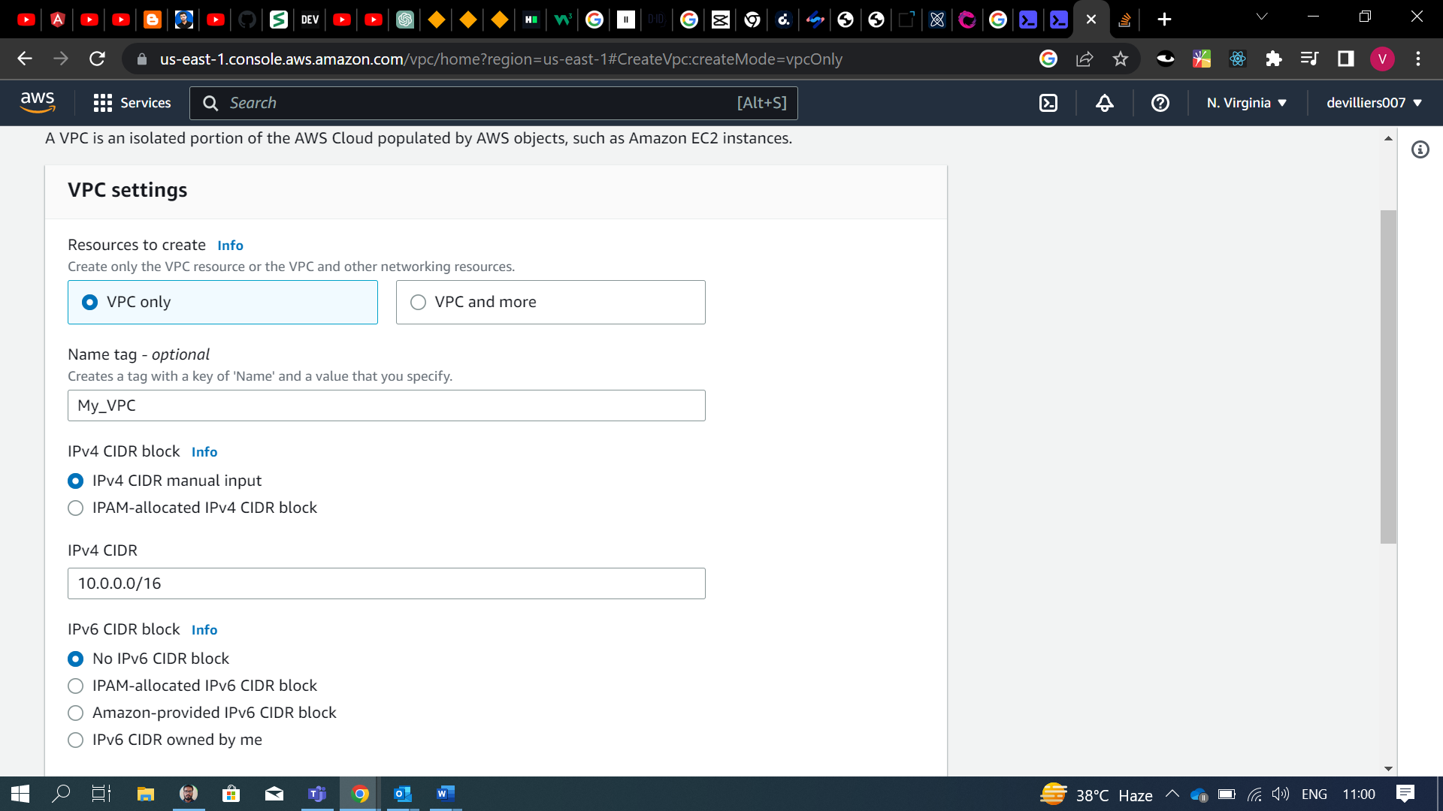

**Creating Subnets**

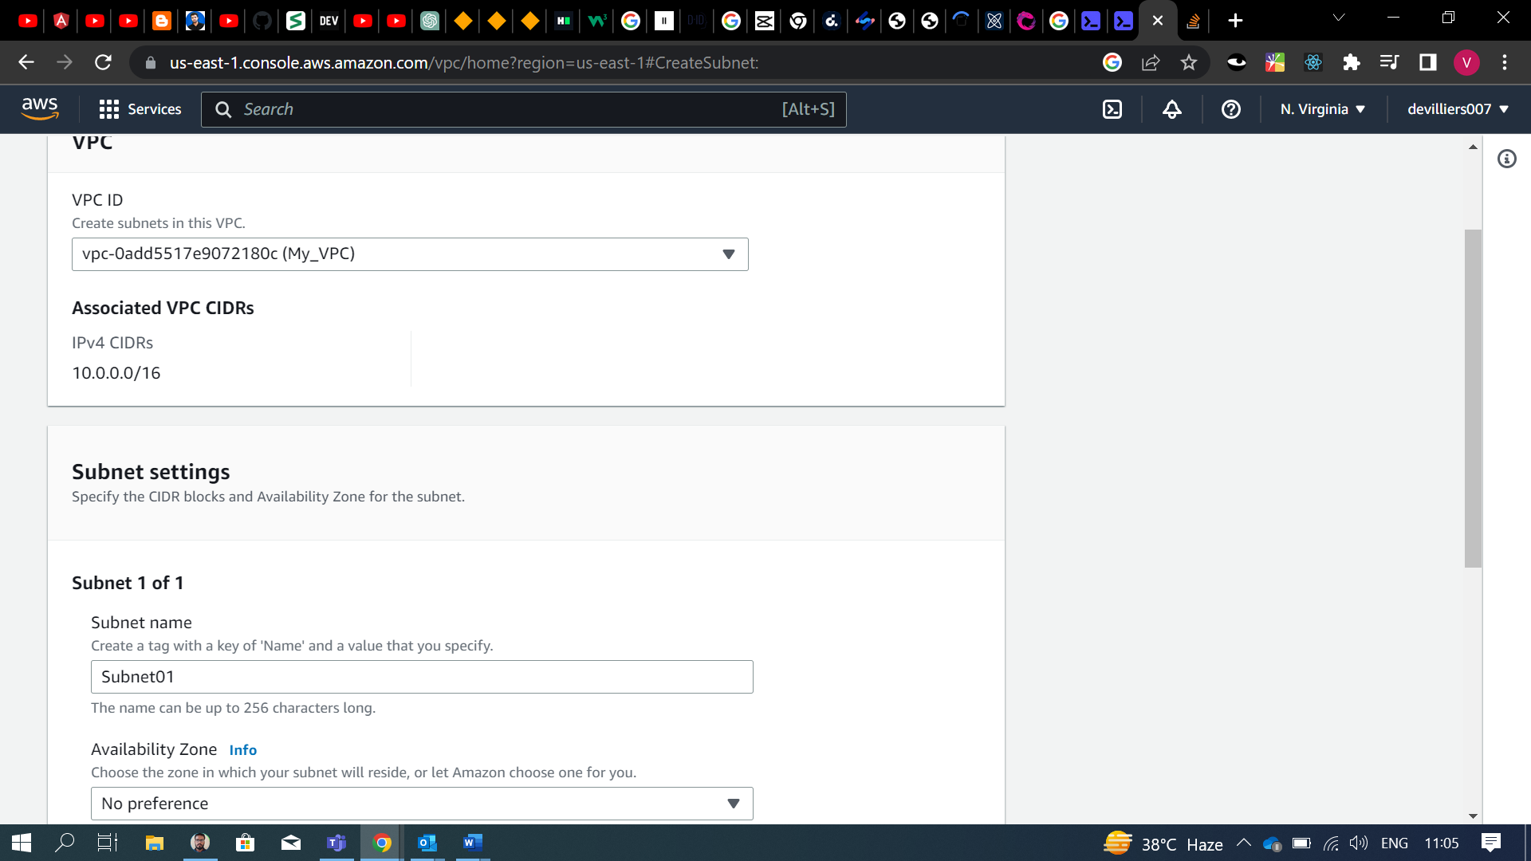

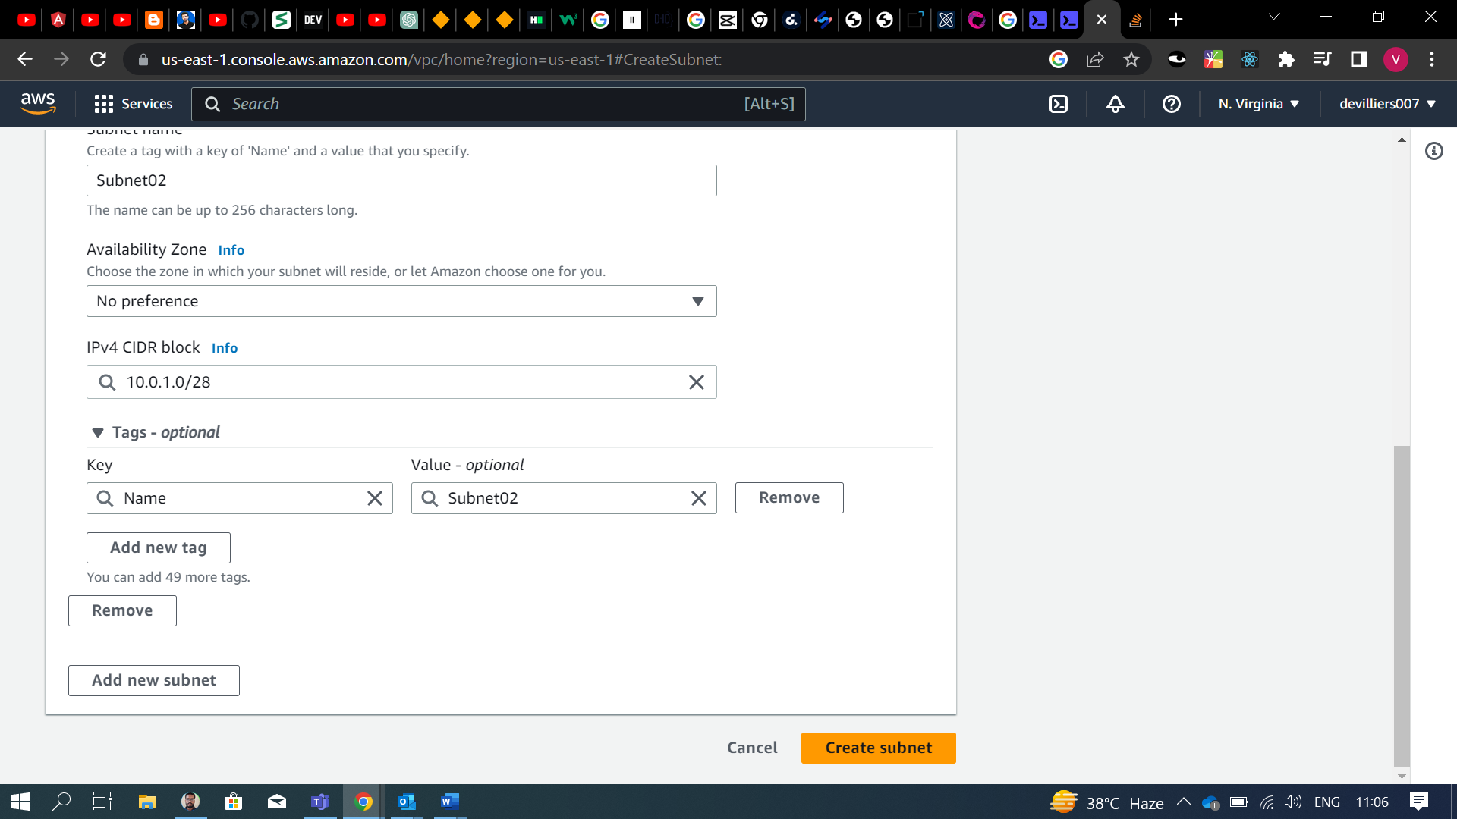

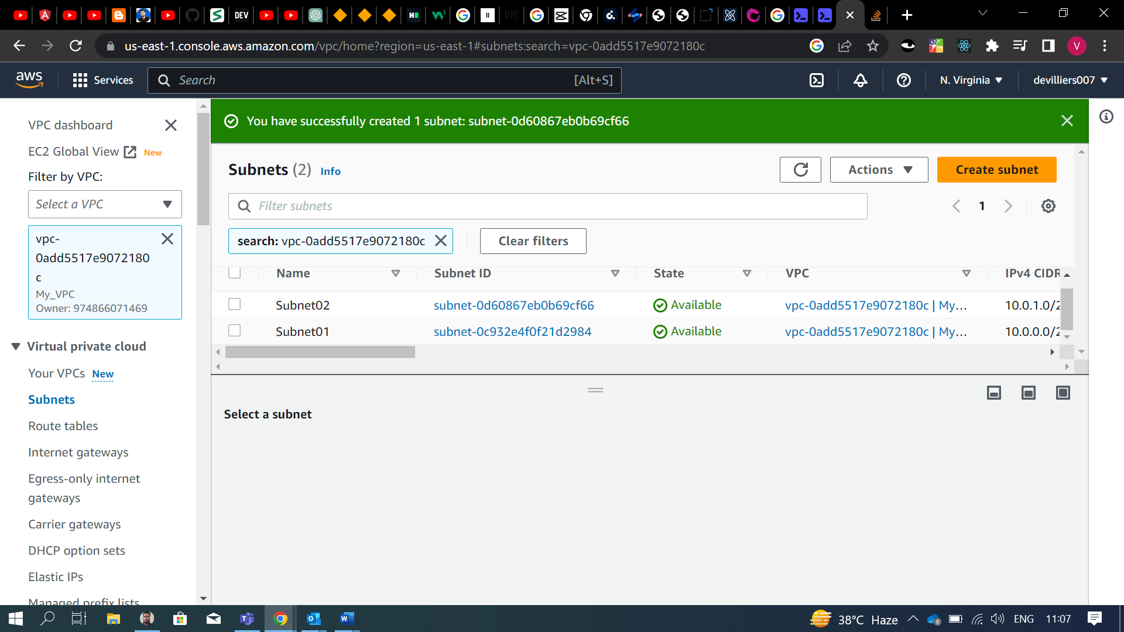

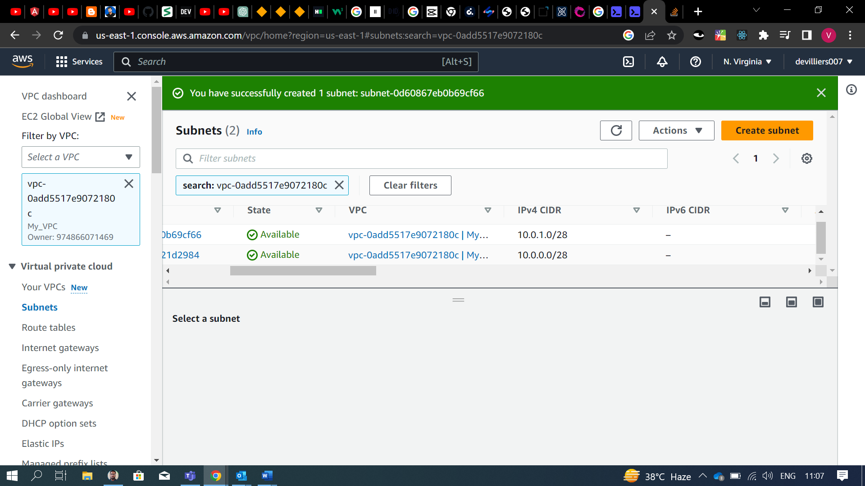

**2. Inside one of the subnets, create a VM and deploy an application code inside it (any existing application created by you before). Make sure to use appropriate NACLs and SGs.**

**Creating VM (windows server)**

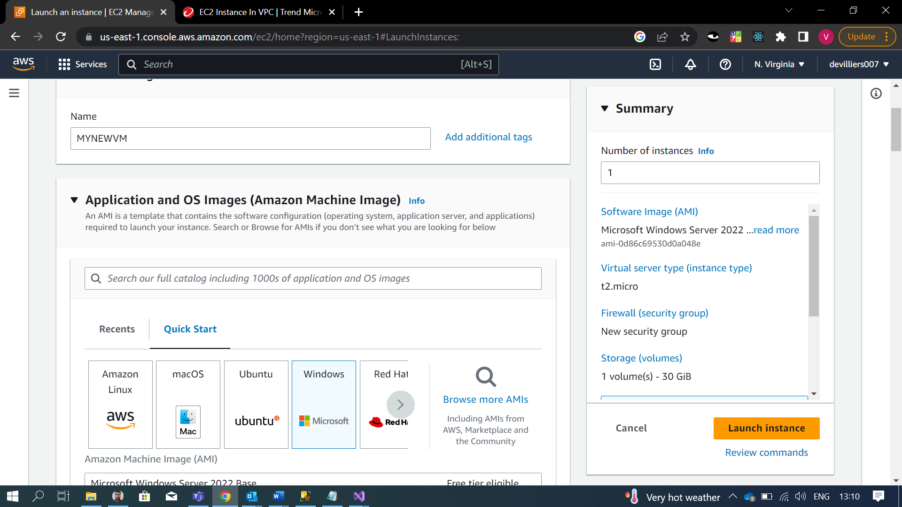

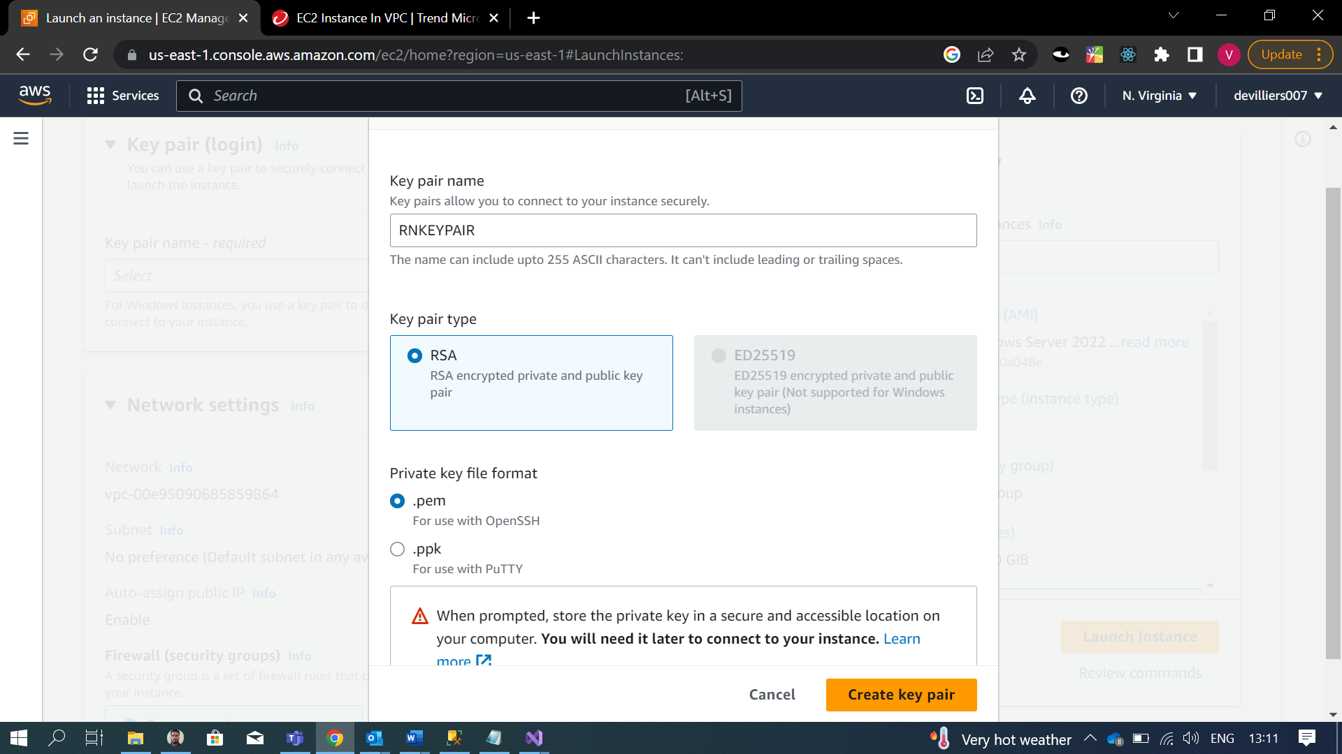

**Setting Up Web Server on EC2**

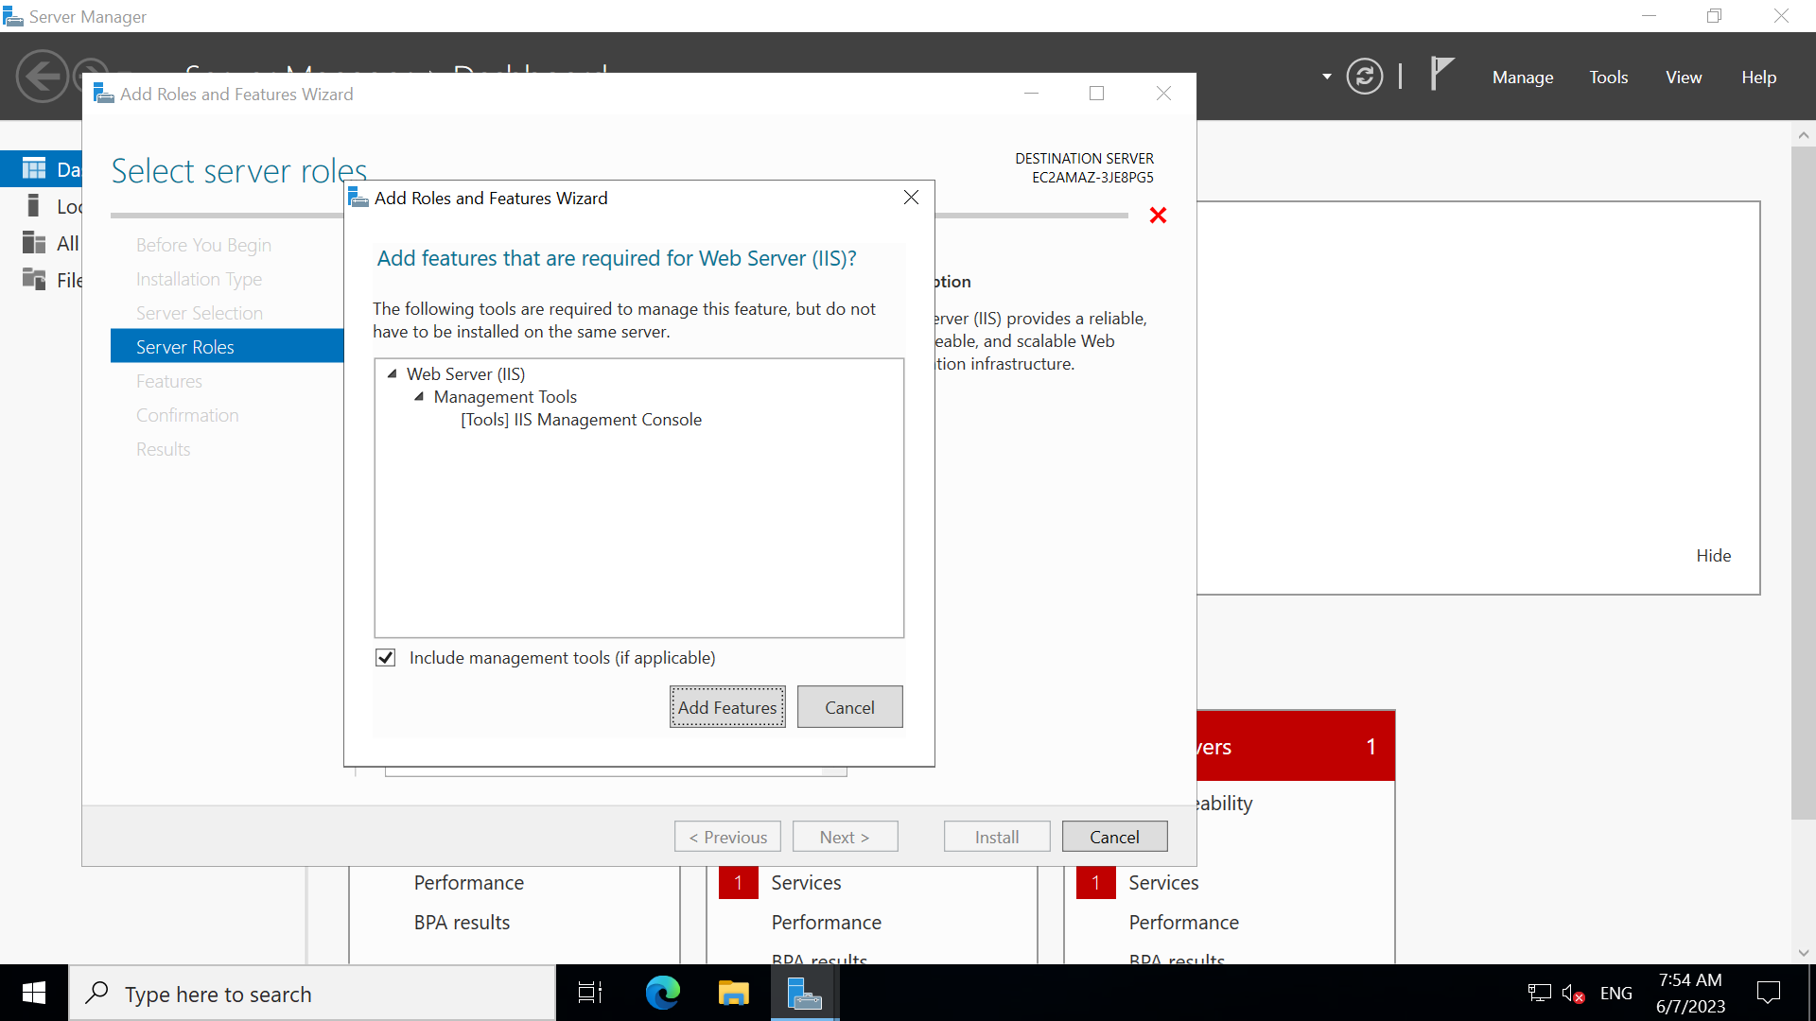

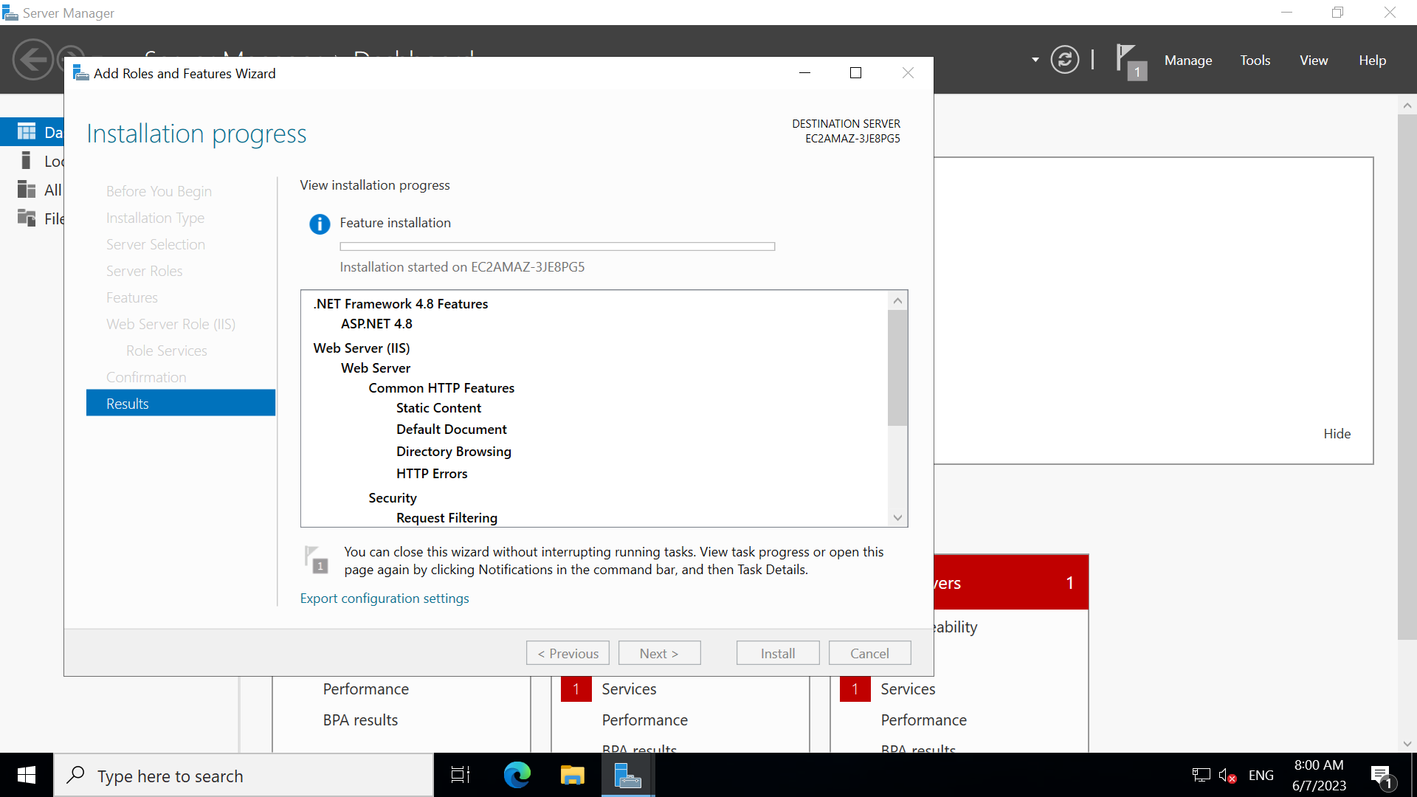

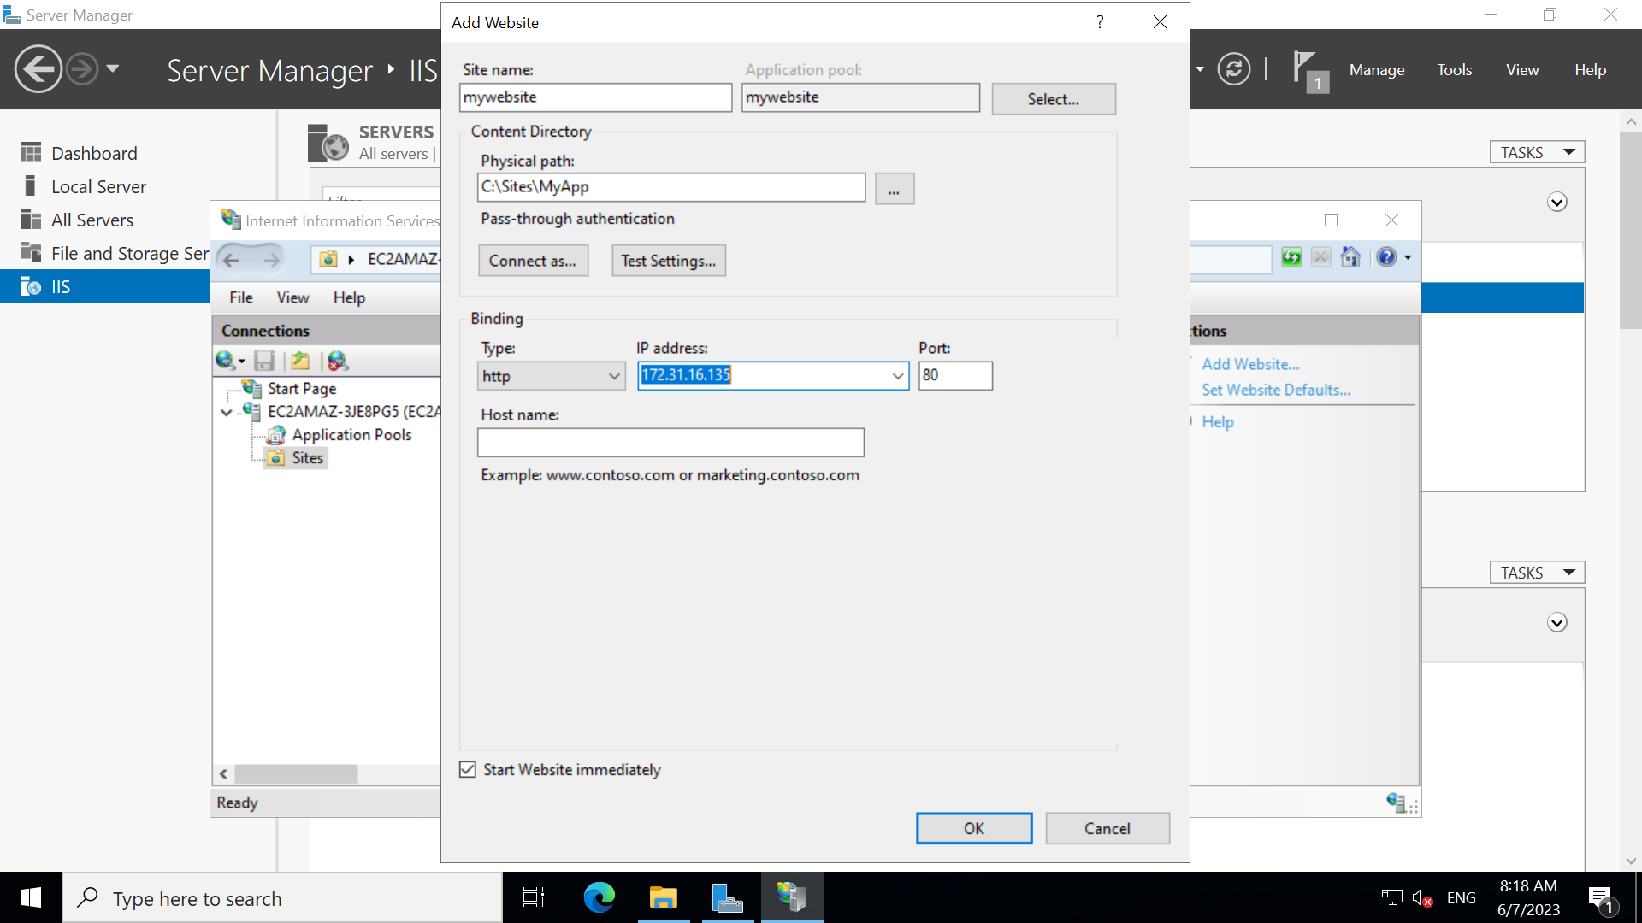

**Created Build from Visual Studio**

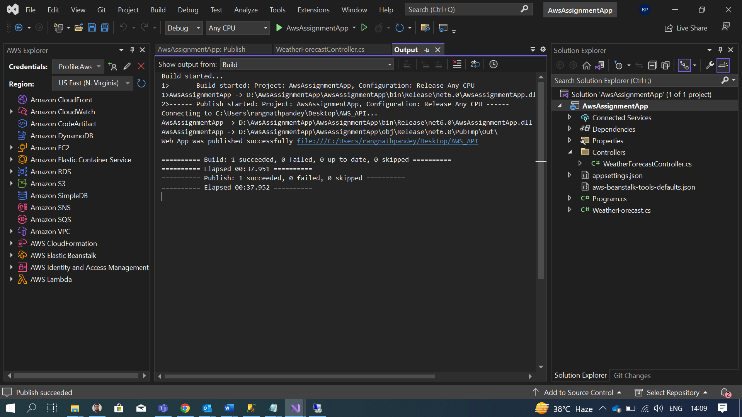

**Uploaded Build to Remote server**

**Restarted the Website**

Api is deployed and we can get data

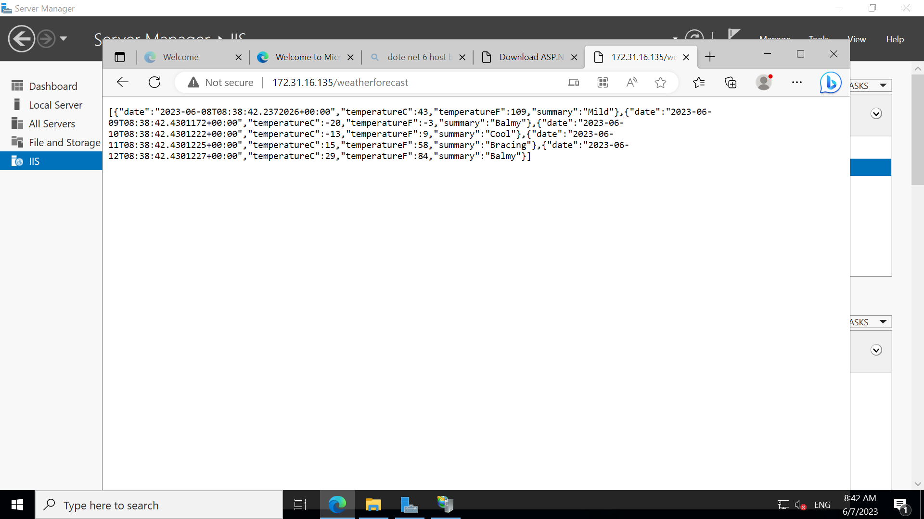

3. **Deploy the same application to Elastic beanstalk Service.**

**Installed AWS toolkit for visual studio and did profile set up**

**Then published same application on AWS Elastic beanstalk.**

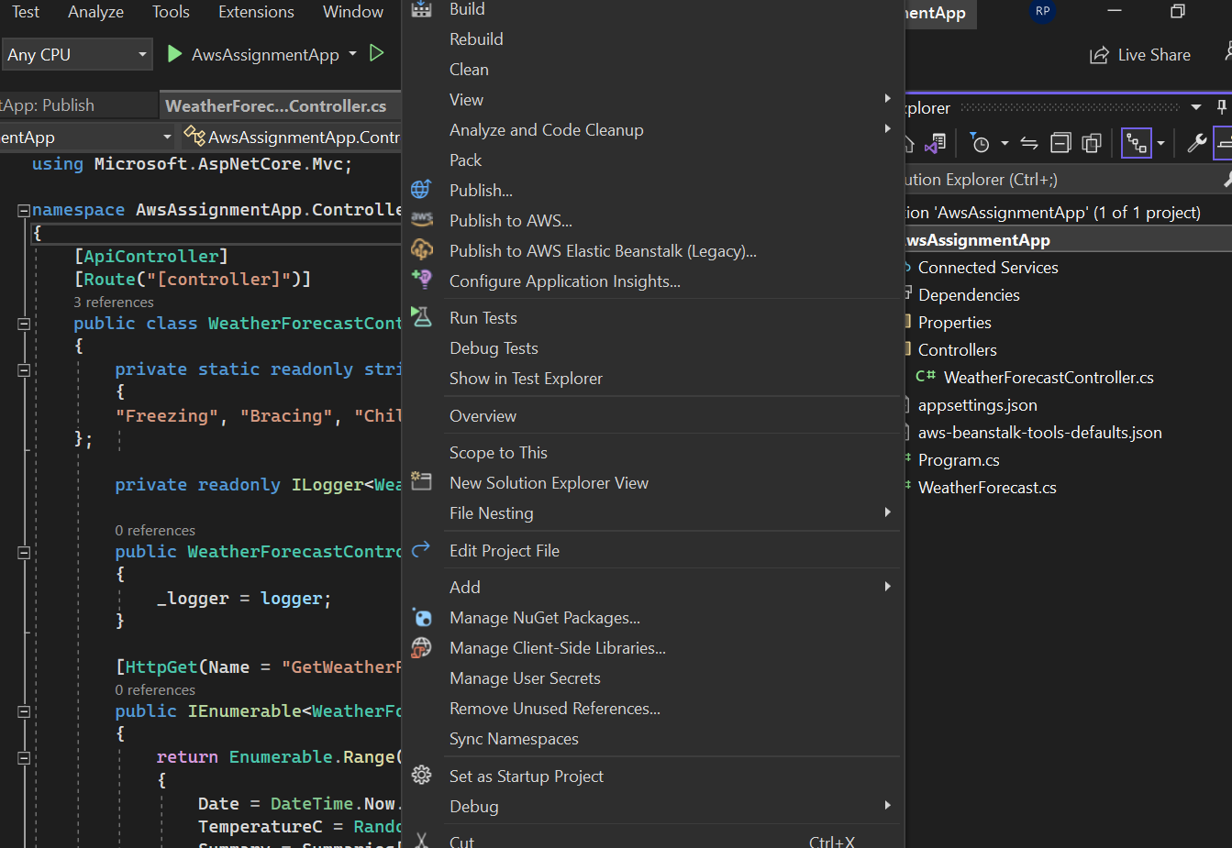

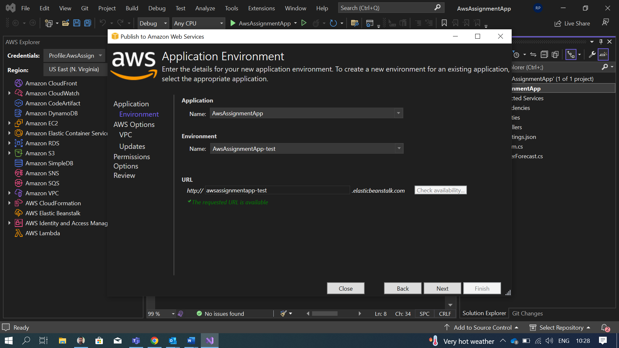

**Created Role**

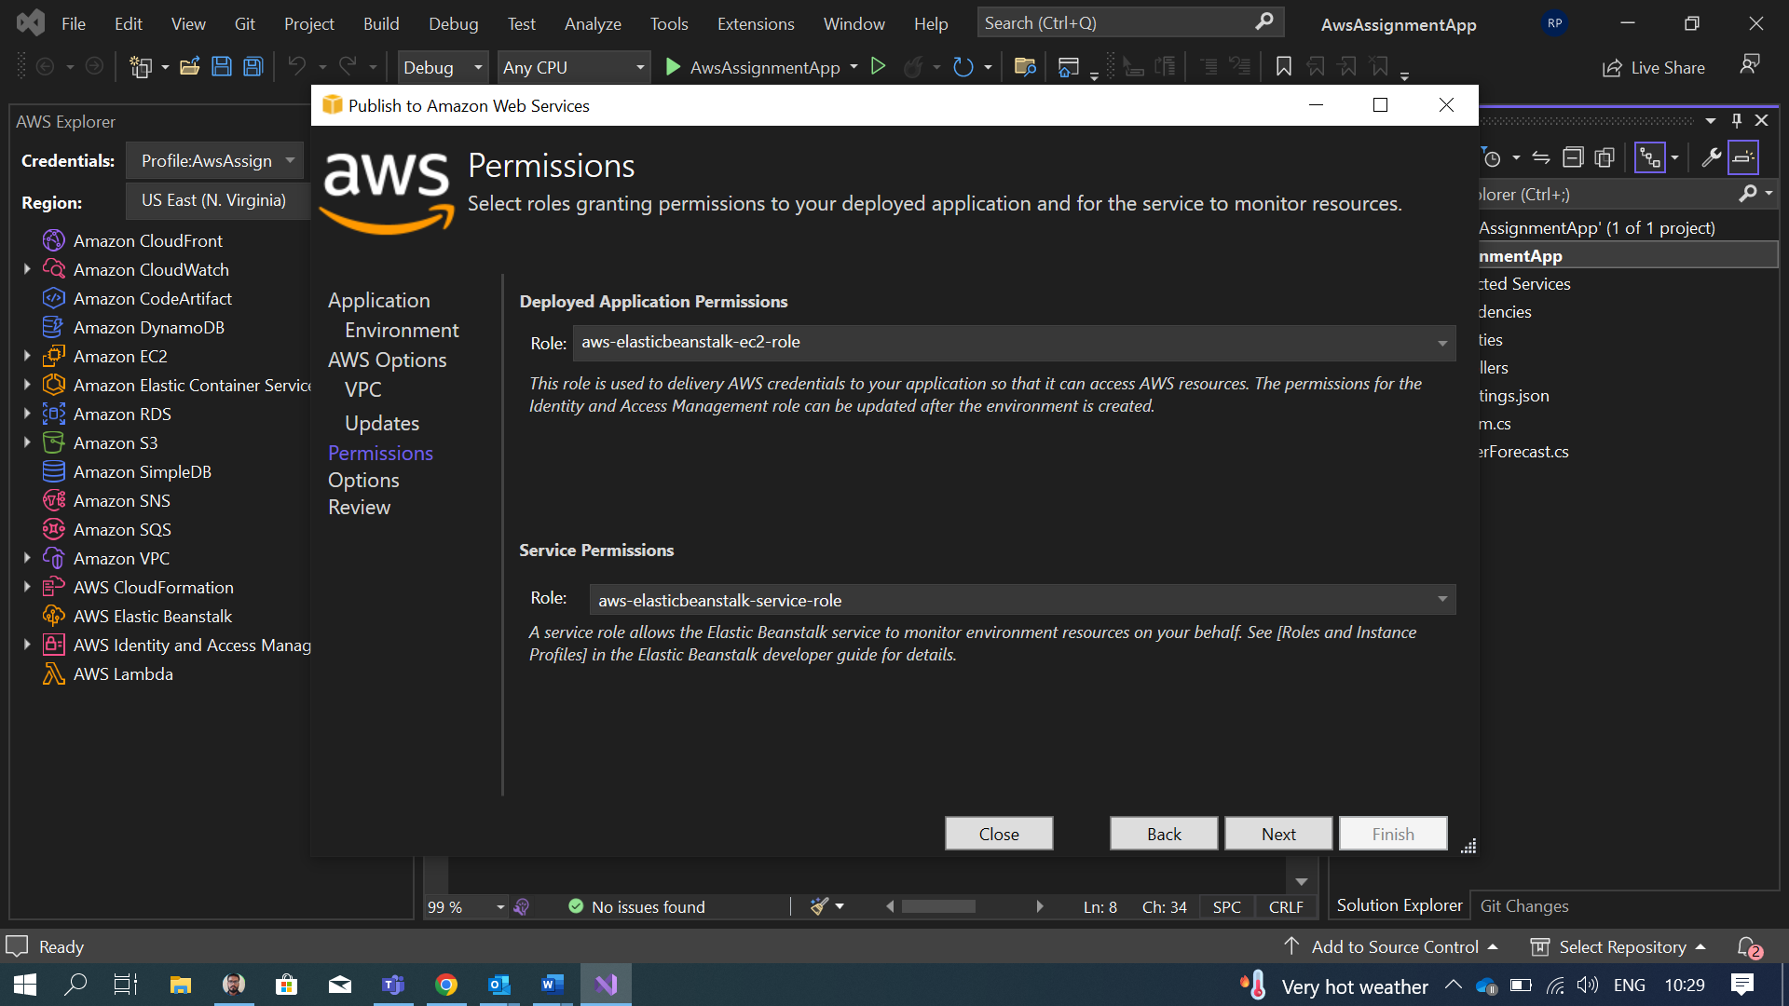

**Publishing the Application**

**Published Application**

4.

**Create a Lambda that should trigger as soon as you upload a file in the S3 bucket.**

**Function should be able to print the name of the file uploaded in the function.**

**S3 bucket Creation**

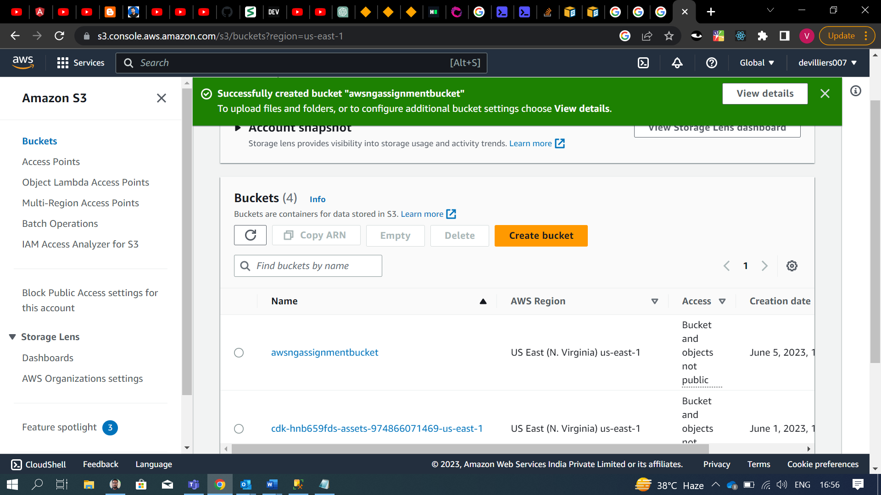

**Lambda Function Creation:**

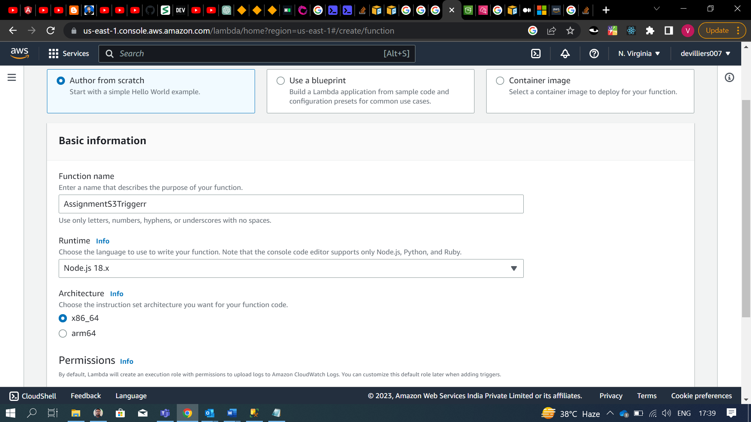

**Adding Trigger:**

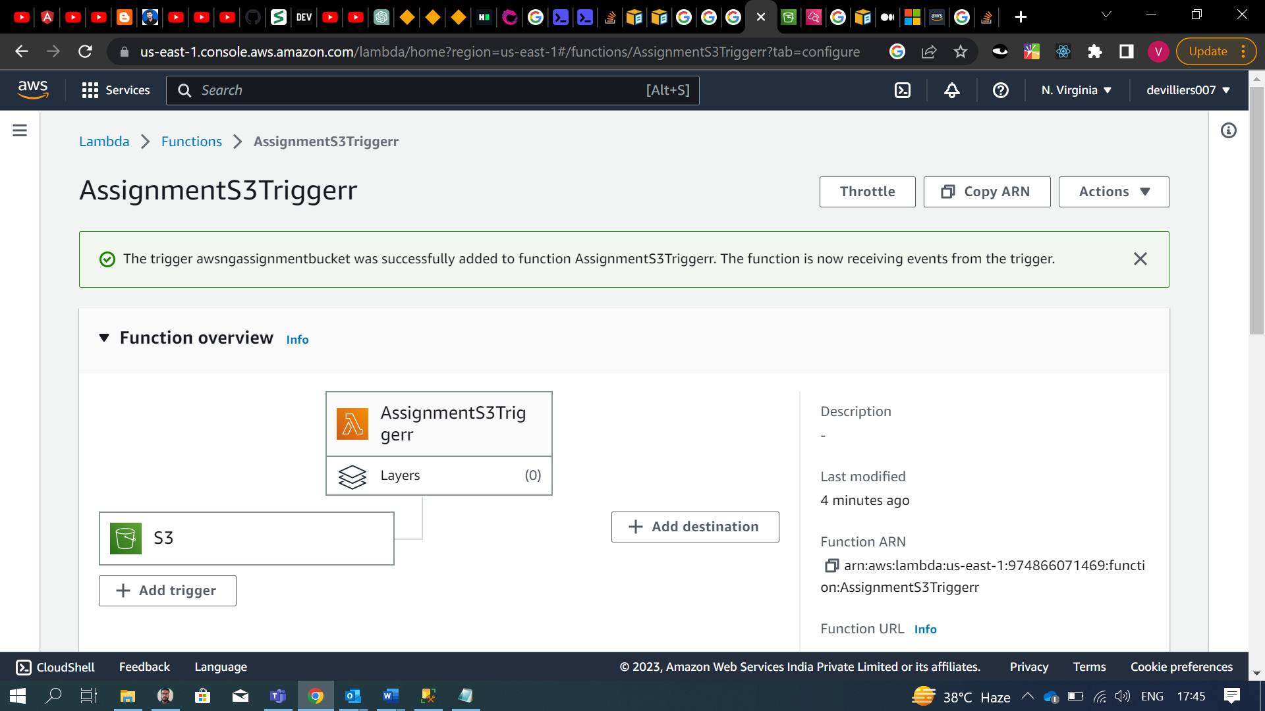

**Triggering Function**

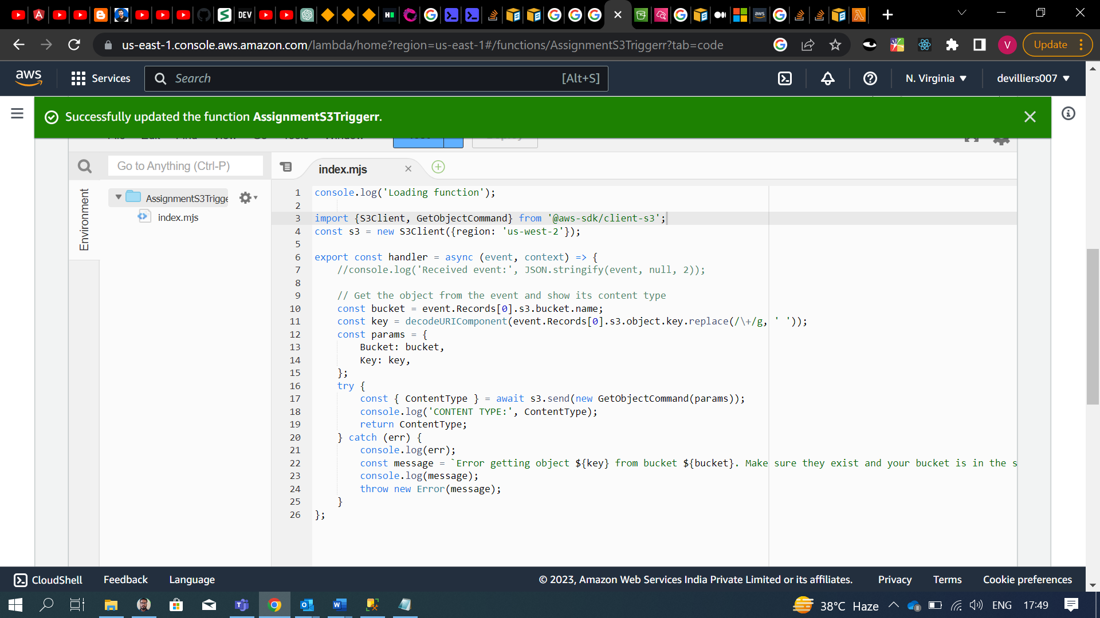

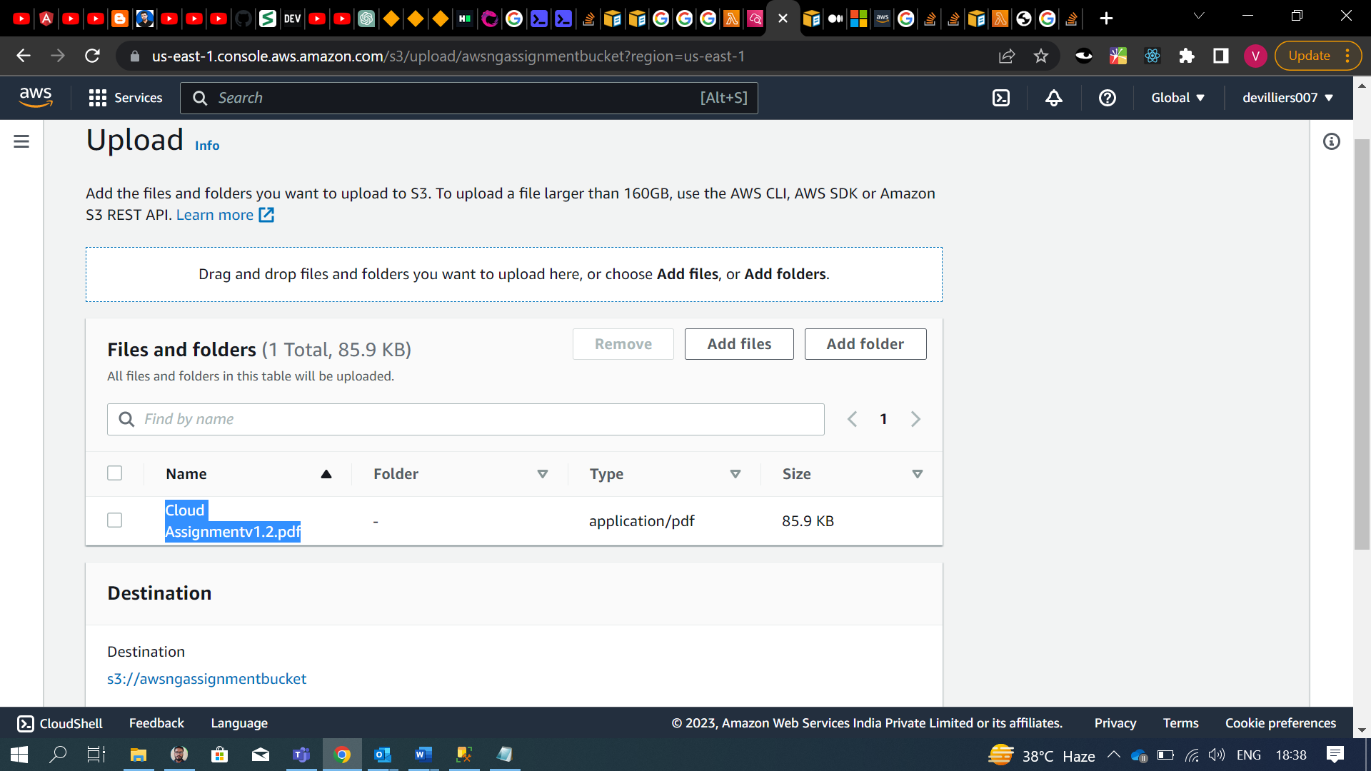

**Uploaded File Name is: Cloud Assignmentv1.2.pdf**

**Function Gets Triggered bucket name and file name can be seen in CloudWatch log**

